Quantity Discription -;+VofTds ljj/0f_
- Quantity of Required Materials -आवश्यक सामग्रीहरुको परिमाण)
ljj/0f | O{sfO{ | kl/df0f
ljj/0f | O{sfO{ | s}nfnL | alb{of | 8f]6L | bfr'{nf | afh'/f | hDdf
afnaflnsfx?sf] nflu l6–;6{ | lk; | 2103 | 1076 | 1692 | 1412 | 1775 | 8058

gf]6M afnaflnsfsf] ;+Vof, vl/b cfb]zsf] jvt #Ü ;Dd km/s kg{ ;Sg] 5 .

B. Age Wise distribution -afnaflnsfx?sf] pd]/ut ljj/0f_– l6–;6{sf] ;fOh k|of]hgsf] nflu dfq
pd]/ ;d'x | kl/df0f
pd]/ ;d'x | s}nfnL | alb{of | 8f]6L | bfr'{nf | afh'/f | hDdf
#–% jif{ | 0 | 0 | 227 | 117 | 71 | 415
^–* jif{ | 0 | 0 | 123 | 247 | 430 | 800
(–!) jif{ | 9 | 0 | 27 | 32 | 169 | 237
!!–!$ jif{ | 465 | 219 | 562 | 362 | 424 | 2032
!%–!* jif{ | 1629 | 857 | 753 | 654 | 681 | 4574
s'n | 2103 | 1076 | 1692 | 1412 | 1775 | 8058
Technical Specification, Requirement and Bidding Form
- Technical Specification
ljj/0f | ljlzli6s/0f (Specification)
l6–;6{ ;fOh | # jif{ b]lv !* jif{ pd]/ ;Ddsf] afnaflnsfn] k|of]u ug{ ldNg]
l6–;6{sf] l8hfOg | lk|G6 l8hfOgsf] lrqdf b]vfOP cg';f/sf], sn/ gePsf], uf]nfsf/ 3f6L ePsf]
sn/ / l8hfOg -lrqdf_ | xl/of] v}/f]  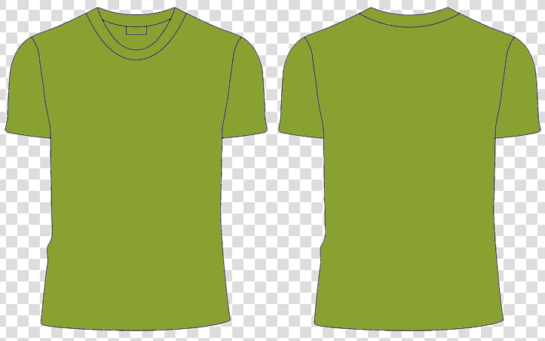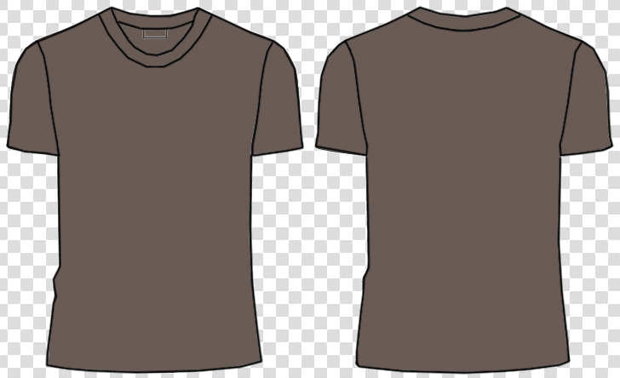  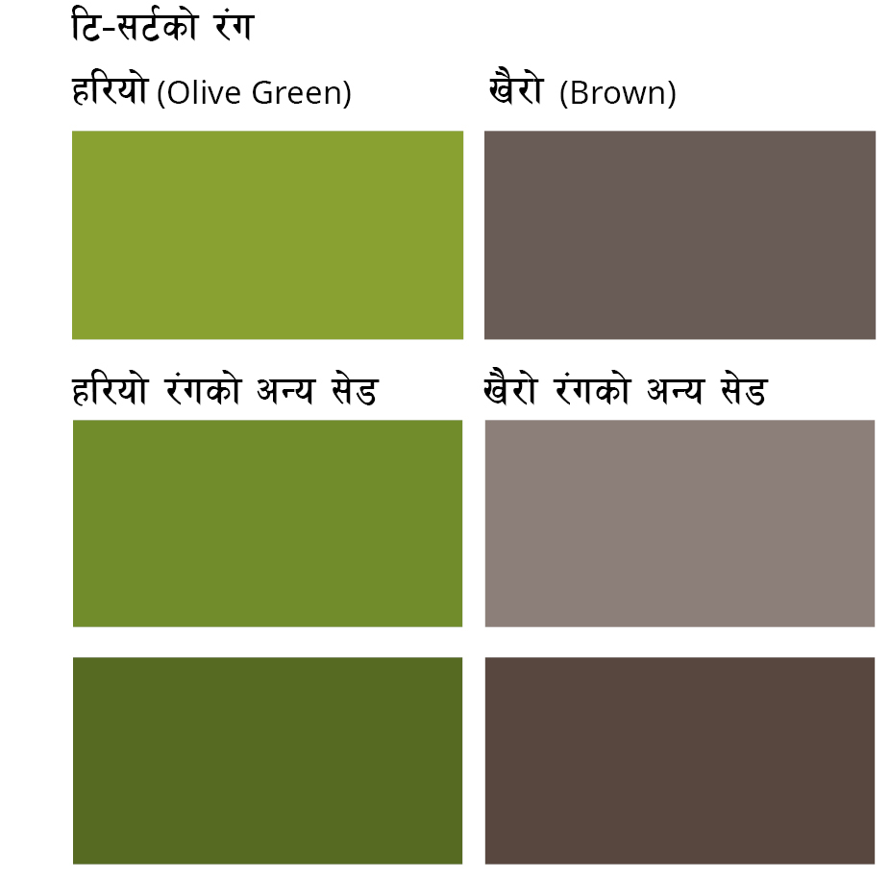
l6–;6{sf] sk8f | s6g÷kf]lni6/ s6g

b/efp kmf/d/Bidding Form

sDklg cg';f/ b/efp v'nfpg'xf]nf / cfjZostf cg';f/ sDklg -a|f08_ sf] nflu nfOg yKg ;lsg]5 .
;dfgsf] k|sf/ | OsfO{ | ;+Vof | a|f08 (Brand)/ sk8fsf] u'0f:t/ | k|lt OsfO d"No ?= -Eof6 ;lxt_ | k|lt OsfOP d"No ?= cIf/df -Eof6 ;lxt_ | s"n /sd  c+sdf | s"n /sd cIf/df | s}lkmot
l6–;6{ | lk;
gf]6 M
!= b/efp k]z ubf{ :ki6 ?kdf c+s / cIf/df d"No pNn]v ug'{kg]{ 5 . ;fy} d"No g]kfnL ?k}ofFdf x'gkg]{ 5 .
@= b/efp k]z ubf{ clgjfo{ ?kdf Eof6 ;lxtsf] d"No k]z ug'{kg]{ 5 .
#= b/efp kq ;Fu;Fu} TOR df pNn]v u/] cg';f/sf] cfjZos sfuhft / ;fdu|Lsf] gd"gf clgjfo ?kdf k]z ug'{kg]{ 5
$+ b/efp k]z ubf{ 9'jflg ;lxt jf 9'jflg afx]s s] xf] k|i6 v'nfpg' kg]{ 5 . olb 9'jflg nfUg] ePdf lhNnfut ?kdf pNn]v ug'{ xf]nf .

